Little SPARK: Simple Play Adaptations to Reference for Kids

Matching Picture Lotto BINGO Built-in Switch Game
Description: | Image:
Game board is mounted on an electronic base with nine red LED’s that light up when players match the right picture word cards to the right word and picture on the game board.  Purchasing Information  User’s Manual | 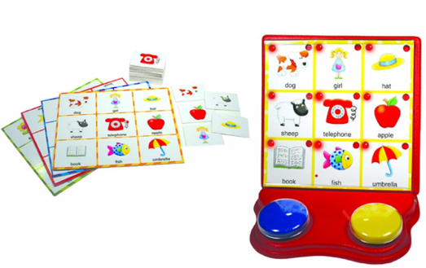

Who Might Benefit?
Those who benefit from switch-activated, visually and auditorily engaging activities that support cause-and-effect understanding, motor skill development, picture-word matching, and peer interaction, while accommodating fine motor and mobility challenges.
Why Use?
Provides an opportunity to promote switch use and scanning skills through multi-sensory, engaging experiences that support hand-eye coordination, problem-solving, word and picture identification, and cooperative play behaviors like turn taking.
Instructions for Use: | Adaptation Ideas:
Environmental Considerations  - Use in any environment including community, home, and school on a flat surface.  Positioning  - Use in seated position at a table or on the floor, standing at a table, or lying on the floor.  Basic Play/Use  - Each player takes turn picking picture cards to match. First player will all 9 matches wins.  Alternate Positioning  - Place spinner on tilted surface such as a 3-ring binder and stabilize with Dycem, shelf-liner, or Velcro for easy viewing.  Extended Play/Use  - Matching the word only or picture only on the back of the picture on the playing board.  - Play bingo.  - Add “wh” questions.  Play/Use with Others  - Model turn taking or develop a script for turn taking. | Build It Up  - Enlarge switch surface with foam board.  Stabilize It  - Encourage the child to rest their forearm on the table while engaged in the activity.  - Use Dycem under the item or attach Velcro.  Simplify It  - Reduce the number of rows or draw cards being scanned.  - Use a fly swatter with center cut out to “frame” the choices one at a time.  Add Sensory Cues  - Apply various textures (e.g. Velcro, Dycem, shelf liner) to switch surfaces to add tactile interest.  Alternative Uses  - Adapt the game for shape, letter, or number recognition by adding game cards for matching.  - Trial different switches.
Words to Encourage Play/Use
Look  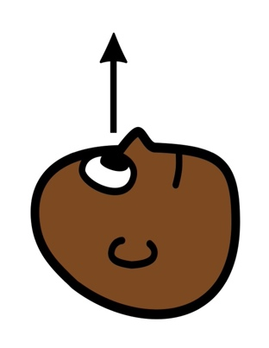 | Find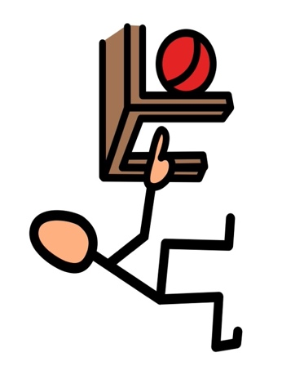 | Push
Stop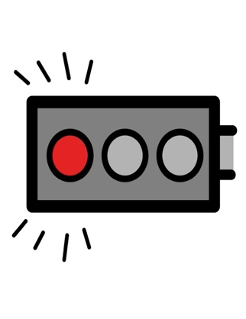 | Go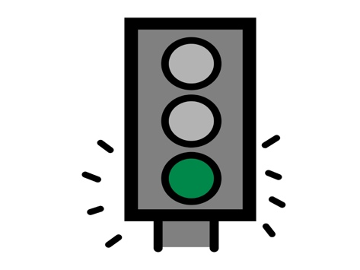 | Same  
Your turn | My turn  | Wait  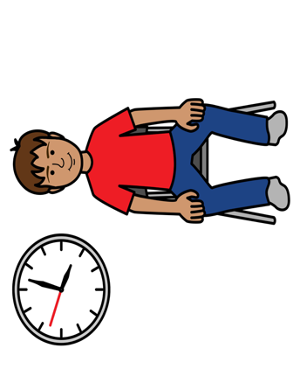
*”Adaptations” adapted from: Haugen’s Modes for Adapting Toys based on materials from the "Let's Play" Project at the University of Buffalo
PCS is a trademark of Tobii Dynavox, LLC. All rights reserved. Used with permissio

